
Edmund Rice Drive, Ashmore, QLD 4214 | PO Box 34, Ashmore City QLD 4214
Ph: 07 5510 2888 | Fax: 07 5510 2899 | Email: transport@aquinas.qld.edu.au

Bus Service Booking Request T2 – T4 2026
** IMPORTANT : This bus booking form and timetable apply to T2-T4 2026 only to support temporary demand. All 2027 bookings will be reviewed in T4 to determine whether the temporary route continues or the original timetable resumes.

Bus Service Required (Please Tick)

Northern Suburb ☐ Helensvale Suburb ☐ Pacific Pines Suburb ☐

Bus Stop : _________________________________________________

1st Passenger |  | AQ ☐ | GA ☐
Name | : |  |  | Mon | Tue | Wed | Thur | Fri
Year Level | : |  |  | AM ☐ | AM ☐ | AM ☐ | AM ☐ | AM ☐
Student ID | : |  |  | PM ☐ | PM ☐ | PM ☐ | PM ☐ | PM ☐
2nd Passenger |  | AQ ☐ | GA ☐
Name | : |  |  | Mon | Tue | Wed | Thur | Fri
Year Level | : |  |  | AM ☐ | AM ☐ | AM ☐ | AM ☐ | AM ☐
Student ID | : |  |  | PM ☐ | PM ☐ | PM ☐ | PM ☐ | PM ☐
3rd Passenger |  | AQ ☐ | GA ☐
Name | : |  |  | Mon | Tue | Wed | Thur | Fri
Year Level | : |  |  | AM ☐ | AM ☐ | AM ☐ | AM ☐ | AM ☐
Student ID | : |  |  | PM ☐ | PM ☐ | PM ☐ | PM ☐ | PM ☐
4th Passenger |  | AQ ☐ | GA ☐
Name | : |  |  | Mon | Tue | Wed | Thur | Fri
Year Level | : |  |  | AM ☐ | AM ☐ | AM ☐ | AM ☐ | AM ☐
Student ID | : |  |  | PM ☐ | PM ☐ | PM ☐ | PM ☐ | PM ☐

AGREEMENT:
Subject to acceptance of this application:
  - I agree to comply with the College’s ‘Terms & Conditions of Student Bus Travel’ outlined on the following page.
  - I confirm that I have reviewed and understand the Queensland Transport Department’s booklet, ‘Code of Conduct for School Children Travelling on Buses’ and acknowledge the College’s commitment to implementing and upholding these guidelines.
  - I will discuss and actively promote safe bus travel practices with my child.
  - I grant permission for my child to travel on the buses to and from all allocated pick-up and drop-off points.
  - I agree to pay invoice for bus travel by the due date. Failure to do so may result in my child’s seat on the service being forfeited.

I acknowledge and will abide by the above agreement.

Reservation request authorised by (Parent/Guardian):
Email Address: ____
Telephone: Date: ___

Parent/Guardian Signature: _______________________________________________________________

Bus Timetables T2 – T4 2026 (Temporary Timetables)

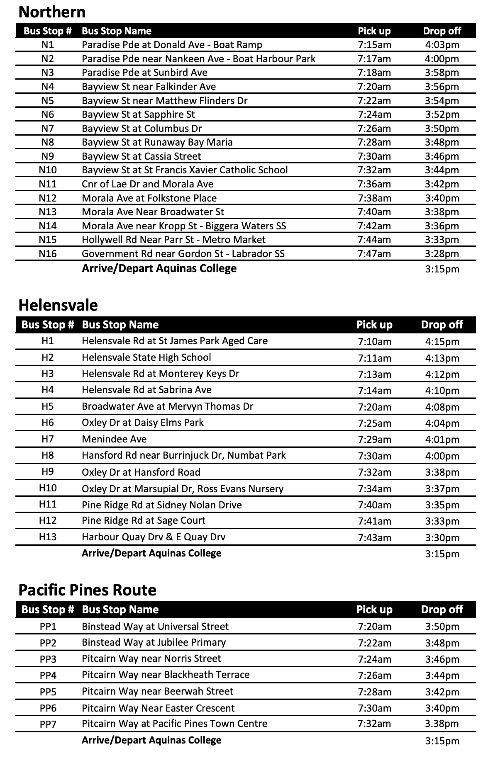

Terms & Conditions of Student Bus Travel

BUS ADMINISTRATION

- Bus travel must be paid upon receipt of College Invoice. Invoices are issued in advance on the last week of the term and the invoices are to be paid in full before the due date to secure the seat. Payment can be made at the College Finance or as per the payment details provided on the invoice.
- For students with permanent bookings, no credits will be issued for absences due to illness, school camps or alternative modes of transport to school on odd days.
- Buses operate on a precise time schedule. If your child is not at the designated pick-up location on time, the driver will wait a short time before continuing the route.
- A $10 charge applies for a new RollCall key fob for new traveller and damaged/replacement key fob can be purchased at the Finance office for $10.
- Students must use their key gob to sign in and out. If the fob is not used for 5 consecutive days, a replacement key will be automatically issued and the $10 will be charged to the bus fee account.

BUS BEHAVIOUR & CONDUCT

- Parent/carers are expected to actively promote and teach safe bus travel practices to their children, in accordance with the College Bus Rules and the Qld Transport requirements for public transport.
- The AQ Transport Team and the College are responsible for students only while they are entering the bus in the morning or leaving the bus in the afternoon.
- The AQ Transport Team adheres to all Queensland Transport legislation regarding breaches of bus student conduct and any associated consequences.
- Students are expected to respect other people and property by:
- Following all directions and instruction given by the bus driver at all times.
- Treating fellow passengers and their belongings with respect.
- Retraining from tampering with or damaging bus property and equipment.
- Student must
  - Use their key fob to sign in and out.
  - Sit properly on a seat and wear a seatbelt.
  - Store bags and belongings under the seat or in designated luggage areas.
  - Speak quietly and avoid creating unnecessary noise
- Student must NOT
- Bully other passengers or driver.
- Engage in fighting, spitting or using offensive languages.
- Throw any objects inside or out of the bus.
- Consume food or drinks (except water) or play music without permission of the driver.
- Smoke or vape on the bus (prohibited on all buses).
- Place their feet on seats
- Allow any portion of their body to protrude from the bus window

IN CASE OF AN EMERGENCY
- Follow all instructions provided by the bus driver.
- Remain seated until the bus comes to a complete stop before attempting to stand or exit.
- Leave the bus in a calm and orderly manner.
- Wait in the designated area as indicated by the bus driver.

